**ASSIGNMENT 23.1**

* Creating database custom:-

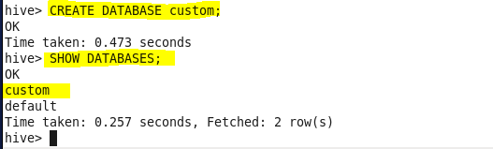

* Using Database:-

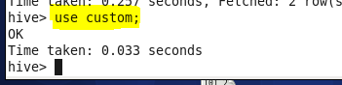

* Creating table temperature_data:-

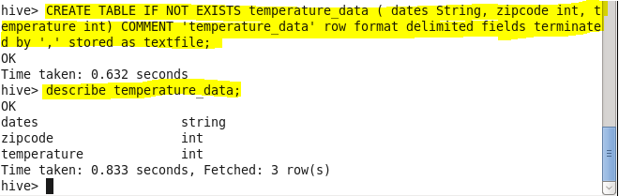

* Loading data into table

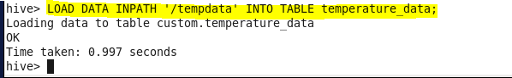

* Output:-

